**How Operations Team work on multiple servers**

* Organizations will have lot of servers and lot of admins
* Creating individual logins on each server for every admin is not a feasible solution.
* An effective way is organization creates a service account for the admins to login and perform administration.  
  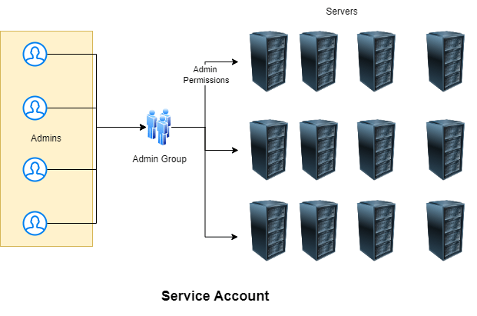
* For the lab activities our service account’s name would be devops
* Having username and password is not a sensible option then how to solve this problem

**How to setup key pair-based authentication in linux machines**

* Key pair is combination of two keys public and private using alortihms, we will be using RSA
* Create a key pair ssh-keygen  
  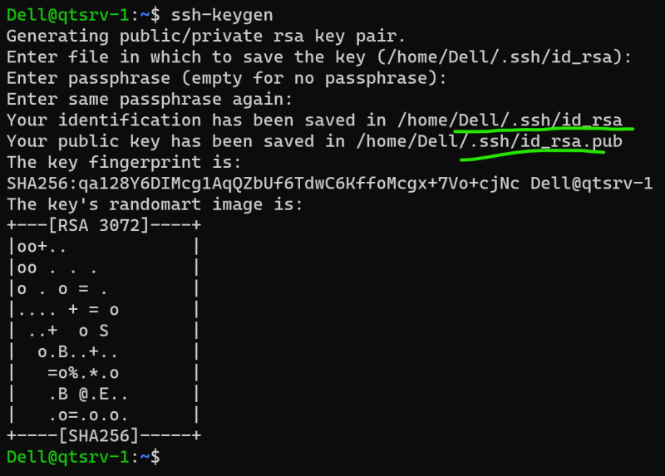
* Copy the public key to linux machine ssh-copy-id username@ipaddress  
  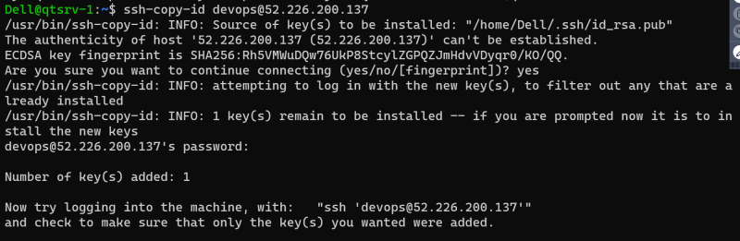
* connect to the machine using private key ssh -i <path-to-private key> username@ipaddress
* Generally private keys created will have extension of .pem
* i.e we create a Service account public and private key. Copy the service account public key to all the servers. disable password based authentication

**Setting up sudo permissions**

* We need to add devops user to the sudoers group (Wheel)
* Execute sudo visudo  
  